After analyzing different attributions of statistics , we could hold some hype testing to check the quality，accuracy , proportion of variances and samples , some estimations made out of our mind , or simply just come from common senses . It is really important to test hyper testing , with elements including null hyper thesis(which is our pre-settled statement ), H1 (alternative hypotheis) , significant value （In this test we always assume it as 5% , according to usual estimation）, and P-value .

**Mean test**

Quoted from BBC news “Let's put the world's average salary - in dollars - of $1,480 a month, or almost $18,000 a year.”[1] Thus, we decide to test if we could get this same conclusions by samples. The null statement should be “mean income for samples is 18000”.

Figure 1 t-test for mean of income

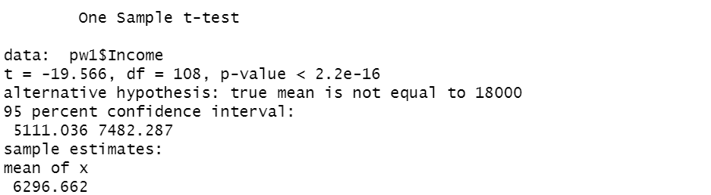

*(Source: author’s own work based on R Studio)*

It turns out we derive result as p value < 2.2e-16, thus we reject this null statement . moreover , the actual sample estimates on Income is 6296.662 .

As a result , we wonder putting more developing countries than developed country into sample is the reason why we get this .

Following would we have proportion test.

**Proportion test**

Development proportion test

We have proportion of developed countries should as least as 50% . Thus we create dummy first, for conveniently holding group-by test later.

Figure2 proportion test for developing courtiers

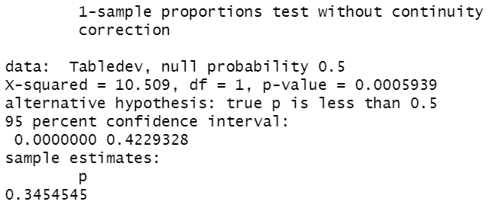

*(Source: author’s own work based on R Studio)*

It comes out the p-value = 0.0005939. The null statement was rejected successfully . The proportion for developed countries are 0.3454545 according to R . It means our guessing that how huge amount of developing countries pulling down the mean of income holds.

**Create dummy**

Create dummy is essential in ratio and proportion hyper testing . By defining “1” and “0” for some certain values. We could get counting tools to calculate samples that have different levels on certain things. For example, we divide the “Happy score “ samples into two groups , one is for the happy score value lower than average score (5.42) , the other is for the happy score is higher than average ， which is so-called “unhappy score”.

**One sample proportion test on happy and unhappy scores**

To test if the samples of low scores and high scores hold balanced volumes, we use proportion testing . Null hyper thesis statement in this question should be : true proportion is less or equal to 50% . H1 statement should be : true proportion is more than 50% . It turns out we get a P value of 17.02% , which is much greater than 5 % , thus we fail to reject null . R provide us a result that the proportion should be around 54.54% . We need ratio test to retest the ratio .

Figure 2 Proportion test

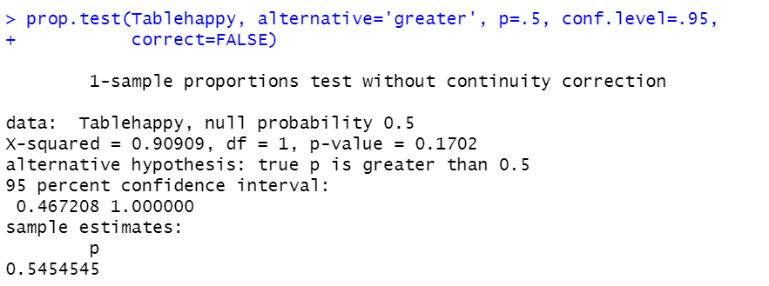 *(Source: author’s own work based on R Studio )*

**Happy score proportion test**

As we divide the “Happy score “ samples into two groups , one is for the happy score value lower than average score (5.42) , the other is for the happy score is higher than average ， which is so-called “unhappy score”. As this dataset is aiming to investigate the only dependent variable , it is the best if samples could have equal distribution on how many “ unhappy scores ” and “happy scores” . We set the statement as : ratio between number of happy score that is upper and lower than mean should be equal to 1 . The variance ratio test turns out that p =48.8 %, fail to reject NULL HYPOTHESIS : ratio of variance is equal to 1 . Actually the ratio is 1.206471 . It is quite near to 50% . it means we have relatively equivalent volumes on happy score scales . The conclusion we derive later on the endings is not biased , but relatively fair

**GDP growth proportion test**

In past experience , the whole world has a very extremely greatly variance on GDP growth . But in this dataset , we still need to test how equivalent the countries we have . Here it has the statement : ratio between number of lower-GDP-developing- speed countries and higher-GDP-developing- speed countries should be 1 .

Figure 3 Code for testing GDP ratio

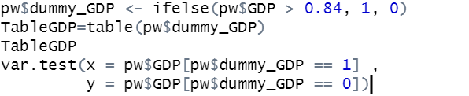

*(Source: author’s own work based on R Studio )*

As a result , its P value is round 1%, we fail to reject null hyper thesis , which reflects our guessing before : the whole world has a very extreme greatly variance on GDP growth ，so that our sample is not well- distributed on GDP growth scale . But overall it will not have influences on how fair our conclusion would be ,

**Higher-income countries proportion test**

Figure 4 proportion on higher-income countries testing

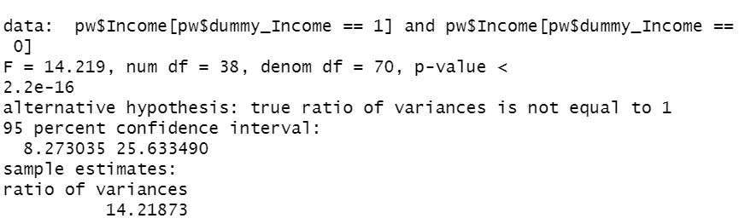

*(Source: author’s own work based on R Studio )*

As we have tested GDP ratio , we could also generate more insights on income testing —— as we know , income could be one of the top elements that effects GDP . We still assume that ratio of income variances batten lower income and higher income is equal to 1. “Back in 1800, global inequality between countries was much lower than it is today.” [2], said by M.Roster . But it turns out P value is even smaller than 2.2e – 16 , so that we reject NULL HYPOTHESIS . It means our samples of income variable has a big variance . The smaller value could be extremely smaller than bigger values .

**Expected value test**

Figure 5 expected value test

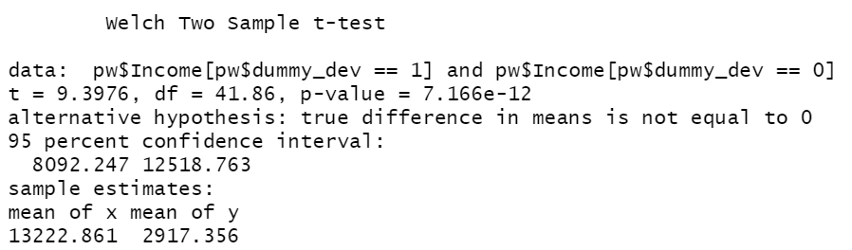

*(Source: author’s own work based on R Studio )*

It deserve to test expected value of income should be equal between developed and developing countries . We create dummy and use it to group by incomes , so that we could use t-test to evaluate this hypothesis . It turns out p-value is super small . We reject null hypothesis which is “mean of income for developed and developing countries should be the same ” . It helps us verify the significance of category for countries at different developing level .

1. BBC news , 2020
2. M.Roster , 2019